P425/2
Applied mathematics
June/July , 2019
hours

UGANDA ADVANCED CERTIFICATE OF EDUCATION
RESOURCEFUL MOCKS
APPLIED MATHEMATICS
Paper 2
3hours

INSTRUCTIONS :

- Answer all the eight questions from section A and any five questions from section B.
- Begin each question on a fresh page.

- All working must be shown clearly.

- Silent non – programmable calculators and mathematical tables may be used.

- In numerical work, take

SECTION A (40 MARKS)
- Two events A and B are such that 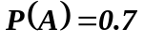 , 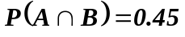 and 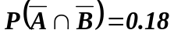.
Find ;
(i) 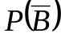
(ii) 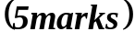

- A particle has forces of 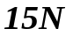 and 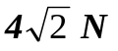acting on it in the direction of the vectors 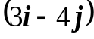 and 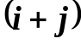 respectively .Determine the
- resultant force
- magnitude of the resultant force.
- Use the trapezium rule with six ordinates to estimate 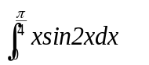 , correct to 3 decimal places.
- The table below shows the expenditure of a certain family during September and October 2018.
ITEMS | EXPENDITURE ( shs) |  | WEIGHT
ITEMS | September | October | WEIGHT
Food | 300,000 | 325,000 | 5
Accommodation | 260,000 | 362,000 | 3
Electricity | 150,000 | 160,000 | 1
Miscellaneous | 620,000 | 725,000 | 2
Calculate the average weighted expenditure index for the months of October based on September 2018
If the expenditure in September was shs1, 350, 000 , use the index above to estimate the expenditure in October
- A particle moving in a straight line covers 12m in 4seconds and 30m in the next 5 seconds of its motion. Determine the
- acceleration.
- initial velocity.
- Show that the equation 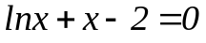 has a root between 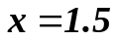and 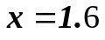
.Use linear interpolation once to estimate the root correct to 3 decimal places.
- A fair die is tossed three times, determine the probability of getting;
- exactly one 2.
- at least one two.
- A car of mass 1,600kg is free wheeling down a hill of slope 1 in 25.When the car descends 200m along the hill, its speed increases from 3ms⁻¹ to 10ms⁻¹.Calculate the average value of resistance to motion.

SECTION B ( 60 marks)
Answer any five questions from this section .All questions carry equal marks.
- The data below show the body mass(x) and the heart mass (y) of fourteen month old male mice.
Body mass (x) | 27 | 30 | 37 | 38 | 32 | 36 | 32 | 38 | 42 | 36 | 44 | 32 | 33 | 38
Heart mass (y) | 118 | 136 | 156 | 150 | 140 | 155 | 114 | 144 | 159 | 149 | 170 | 157 | 131 | 160
- (i) Construct a scatter diagram, draw line of best fit and comment.
- Hence from (i) estimate the heart mass (y) when the body mass (x) is 35.
- Calculate the spearman’s correlation coefficient and comment at 1% level of
significance.

- A steamer moving with velocity 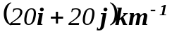 observes a cruiser
at a displacement 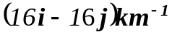away from her moving at a velocity 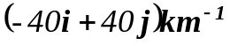.If they remain moving with these velocities , determine the
- time when they are nearest to each other
- nearest distance

- (a) Derive the simple iterative formula based on newton Raphson method for
the equation 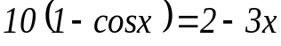 and show that it is given by
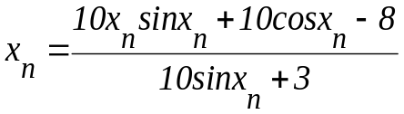 ; 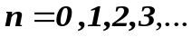
- Construct a flow chart that
- reads initial approximation 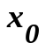
- computes and corrects the root to 3 decimal places:
- prints the root,
- Using 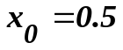 as the first approximation perform a dry run for the flow chart above.

- A continuous random variable X is uniformly distributed in the interval 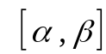
.The lower quartile is 5 and the upper quartile is 9. Find the
- values of and , hence the probability density function
- mean 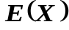and variance 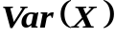
- 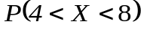

- Three particles of masses 2kg,12kg and 3kg are connected by means of a light inextensible string passing over smooth light pulleys as indicated below

12kg
3kg
2kg
Assuming the strings are vertical, determine the
- accelerations of 2kg,12kg and 3kg masses
- tensions in the strings .

- By drawing graphs of 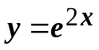and 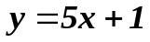 on the same axes ,show that the equation 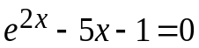 has a root between 0 and 1.0 , correct the root to 1 decimal place. Hence using , the initial approximation and the newton Raphson method , find the root correct it to 3 decimal places.

- A continuous random variable X is normally distributed with mean 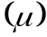 and standard deviation 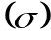 such that 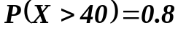 and 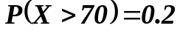
Find the
- values of mean , and the standard deviation
- expected number of 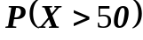 if the total population is 500.

- A particle is projected from point P with an initial velocity of 60ms⁻¹ at an angle of 60 º to the horizontal .At the same instant a second particle is projected in the opposite direction from point Q with initial speed of 50ms⁻¹ at an angle to the horizontal .If P and Q are on the same level and 100m apart, determine :
- the angle of projection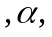 for particle projected from Q.
- when and where collision occurs.

END

